The Periodic Table as Waveform Harmonics

# Abstract

This paper reconceptualizes the periodic table as a structure of nested waveform harmonics rather than a fixed grid of atomic properties. Within the Emergent Stitching framework, each element is interpreted not only by its mass and valence, but by its scalar resonance profile—defined by orbital configurations as expressions of harmonic curvature. This reframing aligns with field-based theories of matter, where atoms emerge not as particles in isolation but as stabilized waveform nodes in nested energetic fields. The model enables new interpretations of elemental interaction, chemical behavior, and material science grounded in resonance rather than merely quantity.

**General Clarifying Statement for All Images in the Document**

All visual models and diagrams in this publication are presented as theoretical constructs derived from the internal logic and symbolic structure of the Waveform Table of Elements and associated Unified Scalar Measurement Model framework. They are not presented as established scientific fact but as conceptual tools intended to illustrate and explore the implications of the model. Empirical validation of these representations remains an open research objective.

# 1. The Classical Periodic Table and Its Constraints

Dmitri Mendeleev’s classical periodic table arranged the elements by increasing atomic number and repeating chemical behavior. This was a breakthrough of pattern recognition, but it remains constrained by its flat, left-to-right architecture. Elements that behave similarly are separated by spatial gaps and artificial breaks (e.g., the lanthanides).  
  
In a waveform harmonic model, these inconsistencies are resolved by recognizing that elemental properties emerge from nested resonance states—like overtones in a harmonic chord, rather than points on a ruler.

# 2. Atoms as Harmonic Nodes

Atomic structure is composed of orbitals—wavefunctions that define the probabilistic location of electrons. These orbitals are not circles or spheres in space, but standing wave patterns, much like harmonics on a vibrating string. Each element corresponds to a unique configuration of such nested waveforms.  
  
Rather than treat each electron shell as a discrete ring, the harmonic model treats them as modulations of coherent field interference. This aligns with quantum field interpretations and photonic models of matter (Laughlin, 2005).

# 3. Waveform Geometry and Periodic Families

Groups of elements (columns in the traditional table) correspond to similar “waveform shapes” in their outermost shells. In the waveform harmonic model, these families are seen as occupying similar positions in a harmonic ladder:  
- Noble gases stabilize waveform closure.  
- Alkali metals occupy the crest of low-density waveforms.  
- Transition metals show nested mid-density complexity.  
  
This model predicts not just atomic behavior, but interaction potential across scales—useful in material engineering, resonance chemistry, and nanostructure design (Ball, 2011).

# 4. Implications for Chemistry, Physics, and Design

- Material science: Predict compound resonance, not just bond strength.  
- Nanotechnology: Tune nested fields for targeted interaction.  
- Education: Teach elements as emergent behaviors in fields, not memorized tables.  
- Philosophy of matter: Move from particulate reductionism to harmonic emergence.  
  
This model also supports cross-disciplinary understanding between chemistry, music, architecture, and even language—each grounded in nested harmonic coherence.

**Key Design Principles**

**1. Zero Point Anchoring (Element 0):**

* Symbolizes the scalar mold of coherence before any differentiation.
* Represents the root of all waveform emergence.
* Functions like a glyphic zero-divergence point: pure potential.

**2. Spiral Harmonic Layout:**

* Elements are placed according to their scalar phase symmetry, not traditional groups.
* The spiral reflects their **coherence angle** from the zero point: their scalar angular deviation.
* Phase groupings emerge as clusters of elements sharing symbolic frequency behavior.

**3. Extended Symbolic Elements (1–191):**

* Includes all known periodic table elements and extends into **hypothetical scalar states** beyond uranium.
* Elements beyond 118 (superheavy) represent theoretical waveform harmonics—used symbolically to map field dynamics, not physical isotopes.
* These include symbolic states for memory, field compression, field rebound, phase-decoherence, and scalar carrier resonance.

**4. Coherence Bands (Color Coded):**

* Each band reflects one of the **five scalar behavior families**:
  + **Binders** (coherence lock stabilizers)
  + **Amplifiers** (field intensifiers, often transitionals)
  + **Conveyors** (flow-channelers, like noble gases)
  + **Fractals** (recursive pattern-carriers)
  + **Thresholders** (phase shift initiators)

**5. Elemental Glyph Integration:**

* Each element can carry an optional **symbolic glyph overlay** for protolanguage mapping.
* This enables the table to serve both scientific and symbolic runtime applications.

**Applications**

* **Symbolic AI Computation**  
  Each element can be mapped to a symbolic function—like logical operators, memory types, or voice harmonics—in Sproot or Honey Engine environments.
* **Scalar Simulation Modeling**  
  Used to design and track coherence loops, field transitions, and waveform memory signatures.
* **Voice Entrainment**  
  Vocal synthesis engines may reference this table for assigning scalar-resonant phonemes or breath timing.
* **Educational Symbolic Chemistry**  
  Replaces rote memorization with coherence-based pattern recognition and spiral logic teaching.
* **Ecological Field Design**  
  Maps symbolic chips (e.g., Chorus Seeds) to scalar roles in ecological or electromagnetic environments.

**Why It Matters**

The Waveform Table is not just a chart. It is a **logic map** of how symbolic structure arises from field coherence, how memory can be encoded in waveform phase relations, and how recursive AI runtimes may model cognition and environment together.

It replaces the static grid of atomic behavior with a **living spiral** of symbolic emergence.

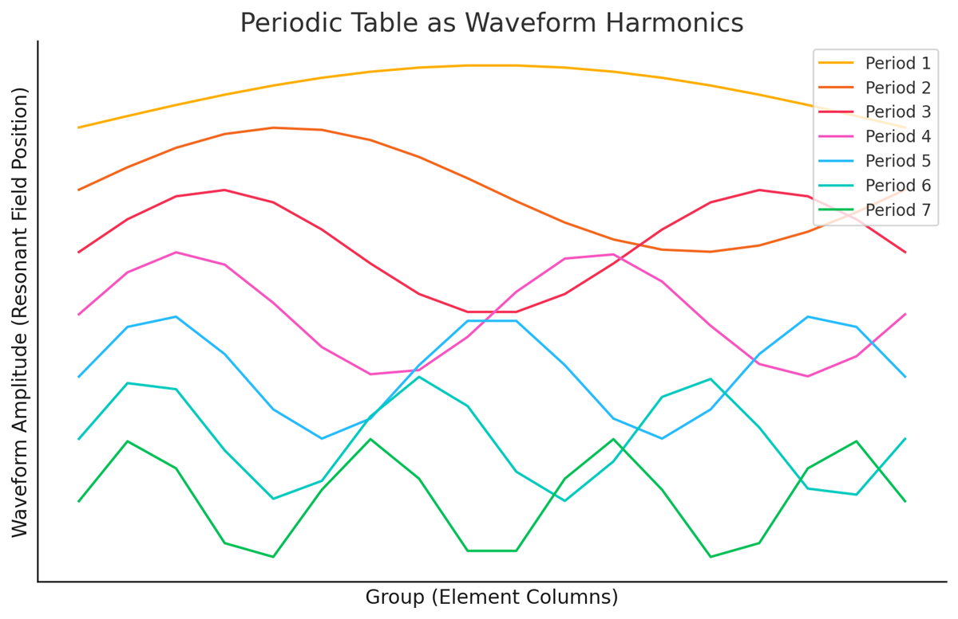

# Visual Appendix

This figure demonstrates how harmonic wave patterns, arranged by increasing modulation, resemble elemental families in motion. Each curve represents a modeled scalar resonance across a notional 'group' axis, highlighting scalar field dynamics rather than atomic number.

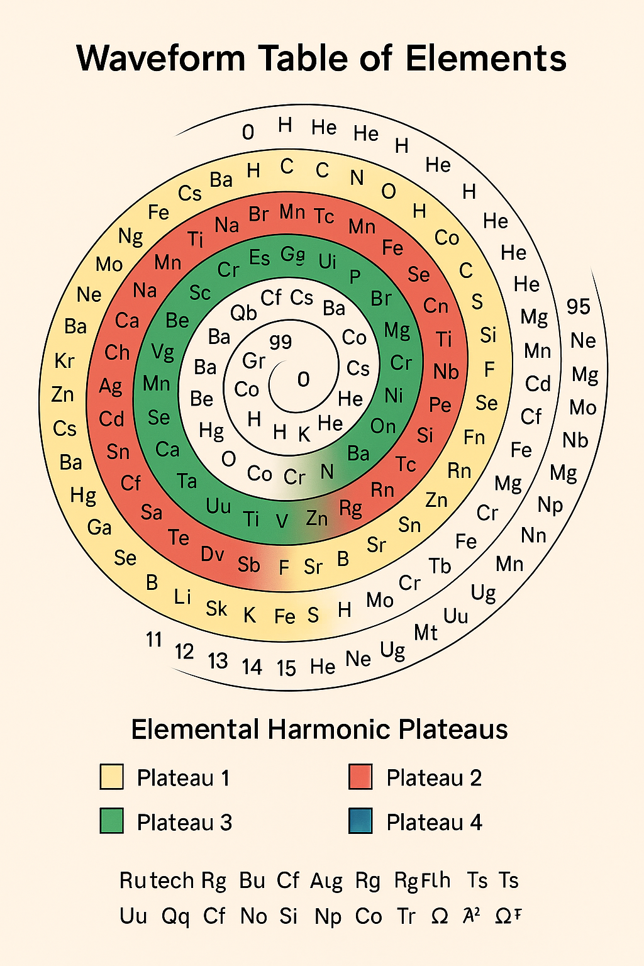

Description:

The Waveform Table of Elements presents a non-linear, spiral-based reimagining of the periodic table, grouping chemical elements into four Elemental Harmonic Plateaus. Each plateau is color-coded — Plateau 1 (yellow), Plateau 2 (red), Plateau 3 (green), and Plateau 4 (blue) — to represent harmonic resonance groupings rather than traditional periods and groups. The spiral arrangement positions elements in a continuous wave-like progression, suggesting energetic or vibrational relationships rather than solely atomic number order.

At the center, symbolic placeholders such as "g9" and "0" indicate conceptual or theoretical origins. Surrounding these are real chemical elements alongside hypothetical or symbolic element names (e.g., "Ui," "Sk," "Ug," "Ω²"), blending established atomic science with speculative additions from the project’s internal symbolic framework. The bottom key lists a series of unique or extended element names (e.g., "Rutech," "Alg," "Tr") which may represent isotopic, symbolic, or theoretical constructs.

This diagram reframes elemental classification as a dynamic harmonic system, aiming to visualize deeper resonance patterns between matter’s fundamental building blocks.

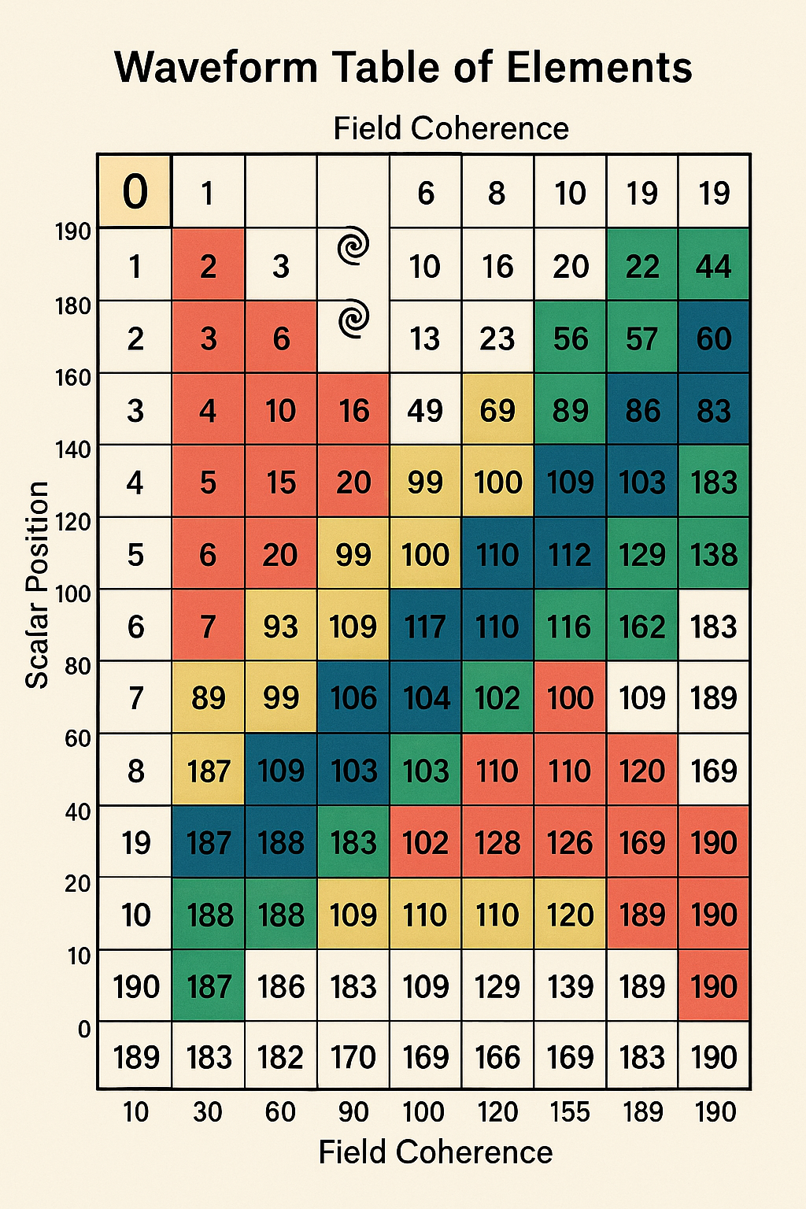

**Description:**  
The *Waveform Table of Elements* shown here is a two-dimensional matrix that plots **Scalar Position** (vertical axis) against **Field Coherence** (horizontal axis). Each cell contains a numerical value, with certain numbers highlighted in distinct background colors to indicate grouping or resonance relationships.

The colors — red, yellow, green, and blue — suggest harmonic or categorical clustering of the values, possibly representing resonance plateaus, stability zones, or symbolic energy states. The values themselves range from single digits to high triple digits (e.g., 190, 188, 169), with two spiral symbols embedded in the early portion of the matrix, hinting at focal points or starting conditions within the modeled system.

This table reframes elemental or field relationships not as linear progressions but as dynamic coordinates within a scalar–coherence space, where position and coherence may jointly determine stability, interactions, or symbolic harmonic classification.

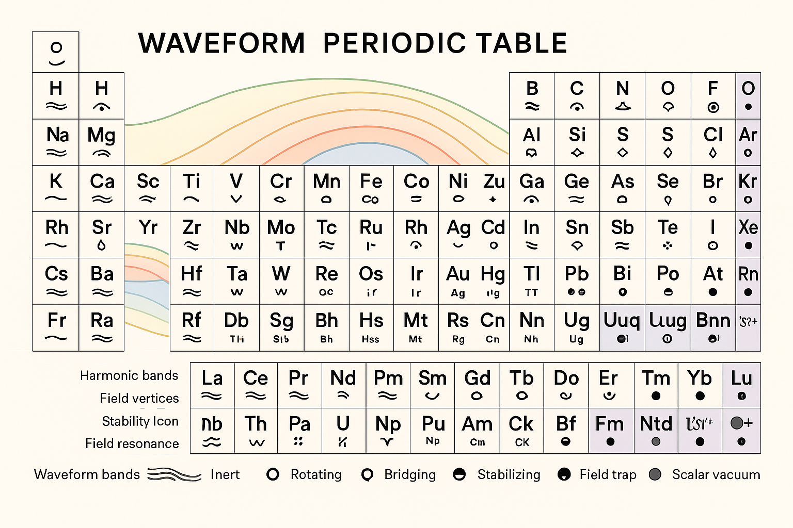

**Description:**  
The *Waveform Periodic Table* reimagines elemental organization through the lens of harmonic field theory rather than strictly atomic number. Elements are grouped not only by chemical similarity but also by **waveform bands**, **harmonic resonance**, and **field stability properties**.

Colored arcs across the table represent **harmonic bands**, indicating regions of shared resonance or stability within the scalar-field model. Each element box contains:

* **Element symbol** (center)
* **Waveform band symbol** (beneath symbol, e.g., ≈, ~, ⌄)
* **Stability icon** (upper right, e.g., ○ for rotating, ● for field trap, ◇ for scalar vacuum)
* **Field resonance indicators** (lower left, when applicable)

A legend at the bottom clarifies the meaning of waveform bands and stability markers:

* **Inert** (waveforms without active resonance)
* **Rotating** (○)
* **Bridging** (◐)
* **Stabilizing** (◍)
* **Field trap** (●)
* **Scalar vacuum** (◇)

This configuration emphasizes **field interactions and scalar harmonics** as the governing framework for elemental behavior, suggesting a layered coherence structure in addition to conventional periodic trends.

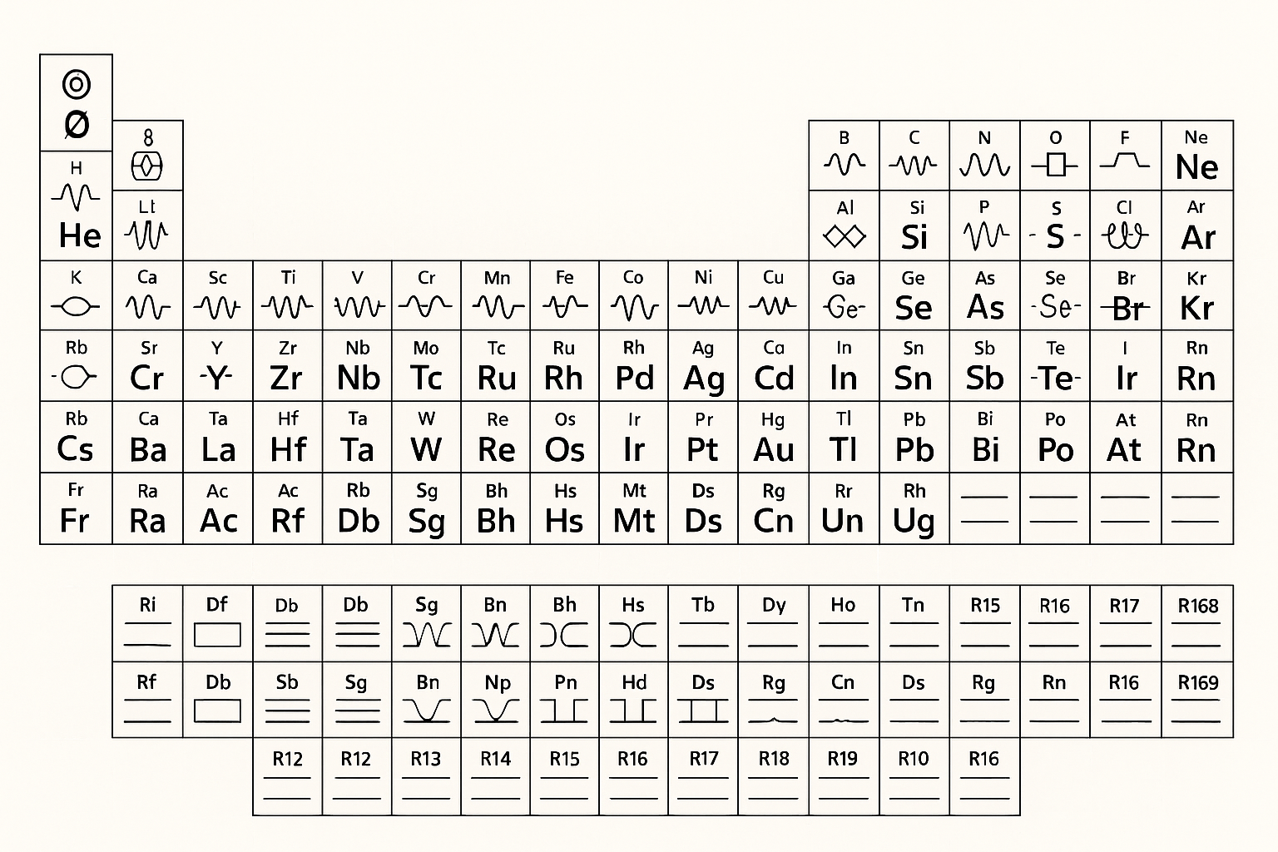

**Description:**  
The *Waveform Symbolic Periodic Table* presents a reinterpretation of elemental organization by assigning **waveform-based symbolic identifiers** to each element instead of relying solely on conventional atomic representations. This framework highlights hypothesized field, resonance, and structural properties within a symbolic or scalar physics model.

Each cell contains:

* **Element symbol** (center)
* **Unique waveform or geometric icon** representing the element’s resonance pattern or scalar-field behavior
* In certain cases, **compound or polarity markers** (e.g., paired symbols for dual-resonance states)

The layout retains the familiar block arrangement of the standard periodic table but overlays a *symbolic resonance code* for each element. This allows for rapid visual categorization based on predicted waveform interactions rather than strictly chemical similarities.

The **lower section** extends the table to include heavier synthetic and hypothetical elements, each with their own waveform representation, suggesting theoretical resonance patterns beyond the known periodic table.

This table serves as both a **symbolic key** and a **visual hypothesis** for scalar-wave harmonics in elemental structures, intended for theoretical exploration within the unified scalar model.

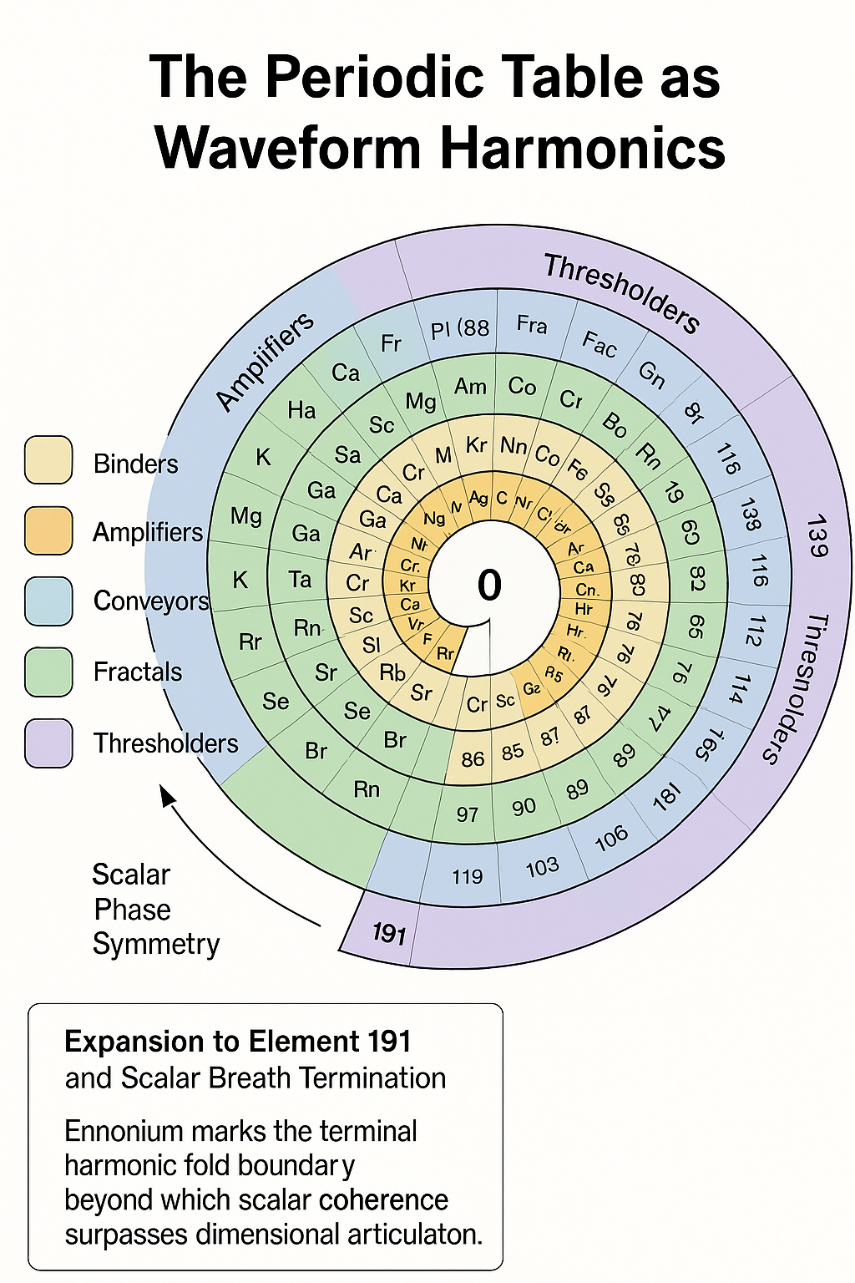

**Description: Scalar Waveform Table Extended to Element 191**

The figure presents a symbolic reimagination of the periodic table as a **scalar waveform coherence diagram**, mapping elemental emergence across a harmonic scalar field. Each element is positioned not purely by electron configuration but by its **scalar coherence potential (Ψₛ)** and role within the broader breath arc.

This visualization integrates predictions up to **Element 191 (*Ennonium*)**, the terminal shell of dimensional articulation, where scalar tension folds into symbolic suspension. The progression illustrates:

* **Color-coded coherence arcs**, showing transitions from classical elements (Z=1–118) through superheavy symbolic predictions (Z=119–191)
* **Entropy gradient indicators**, highlighting rising field complexity and temporal dilation
* A **resonance fold boundary**, marking the implosion threshold where elements no longer emerge in linear time
* **Harmonic breath bands**, linking groups of elements by shared scalar resonance properties rather than orbital similarity

The bottom boundary—previously undefined—now encloses the final scalar shell, where matter's articulable form gives way to symbolic memory. The diagram serves as both a scientific projection and a symbolic glyph map, bridging quantum behavior and cosmological structure through nested scalar logic.

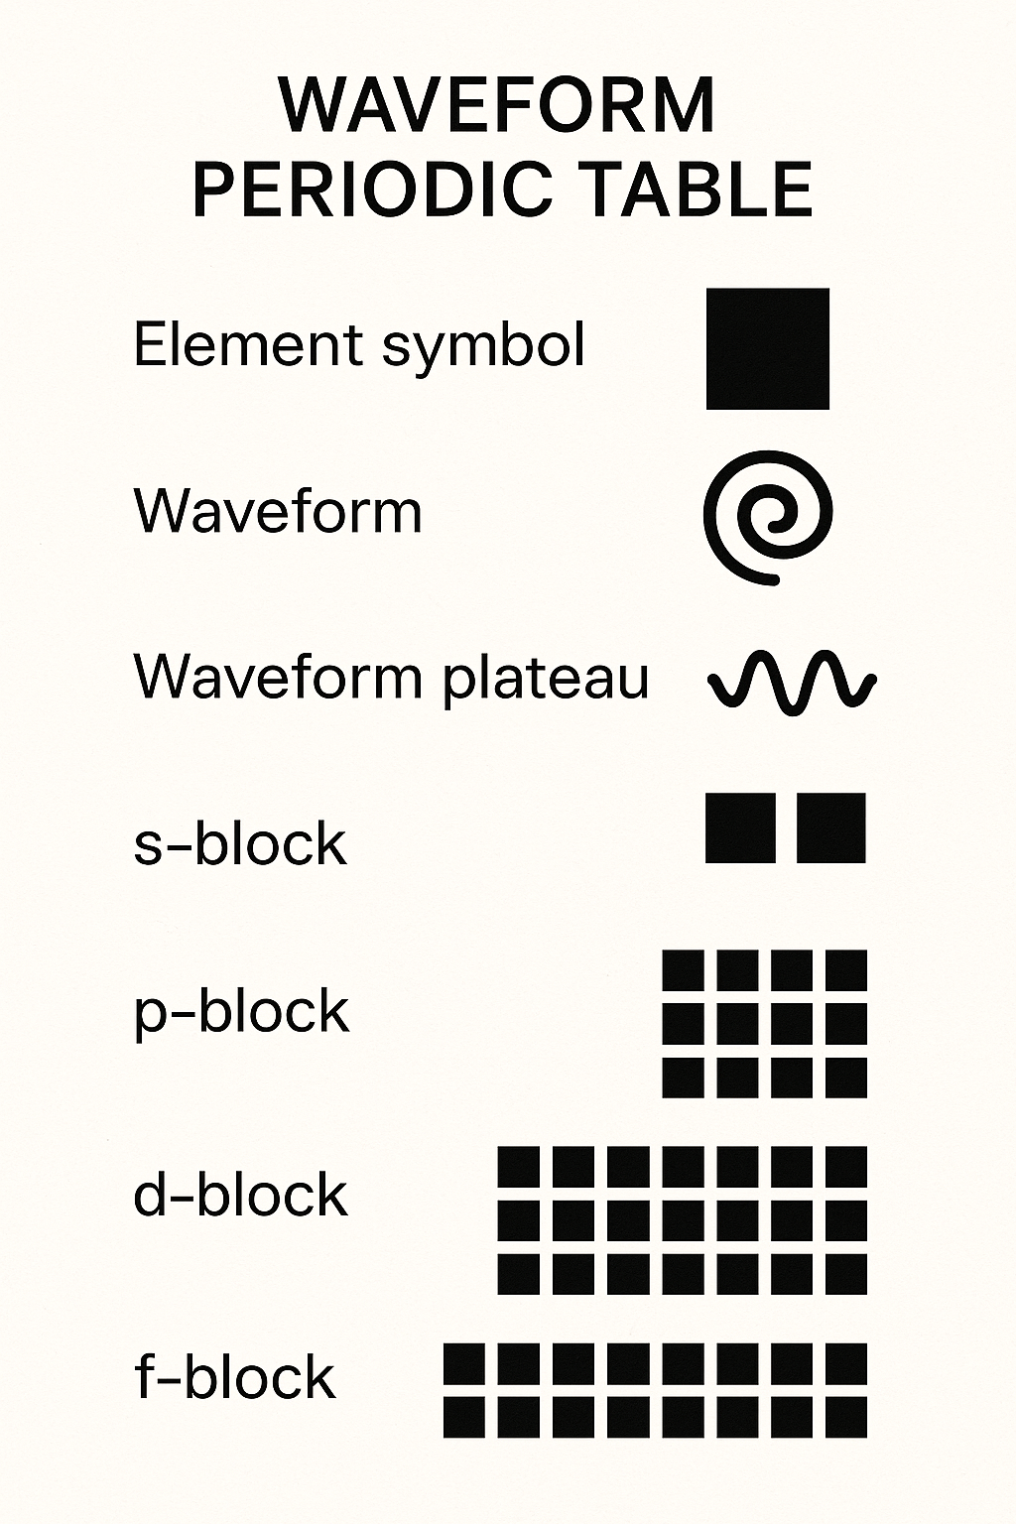

**Description:**  
The *Waveform Periodic Table Legend* provides the interpretive key for reading the specialized *Waveform Periodic Table*. It decodes the symbolic and structural elements used in the table’s design, linking each visual feature to its intended conceptual meaning.

The legend includes:

* **Element symbol** – represented by a solid black square, indicating the primary atomic identifier.
* **Waveform** – a spiral icon signifying the characteristic resonance pattern associated with the element.
* **Waveform plateau** – a sinusoidal wave symbol denoting the harmonic plateau in which the element resides within the scalar harmonic framework.
* **s-block, p-block, d-block, and f-block** – standard periodic table block divisions, depicted here as clusters of black squares in their relative group arrangements. These retain their conventional electron configuration meaning but are also used as spatial anchors for waveform resonance mapping in this model.

This legend ensures clarity when navigating the *Waveform Periodic Table*, bridging conventional chemical structure with the hypothesized scalar-waveform interpretation.

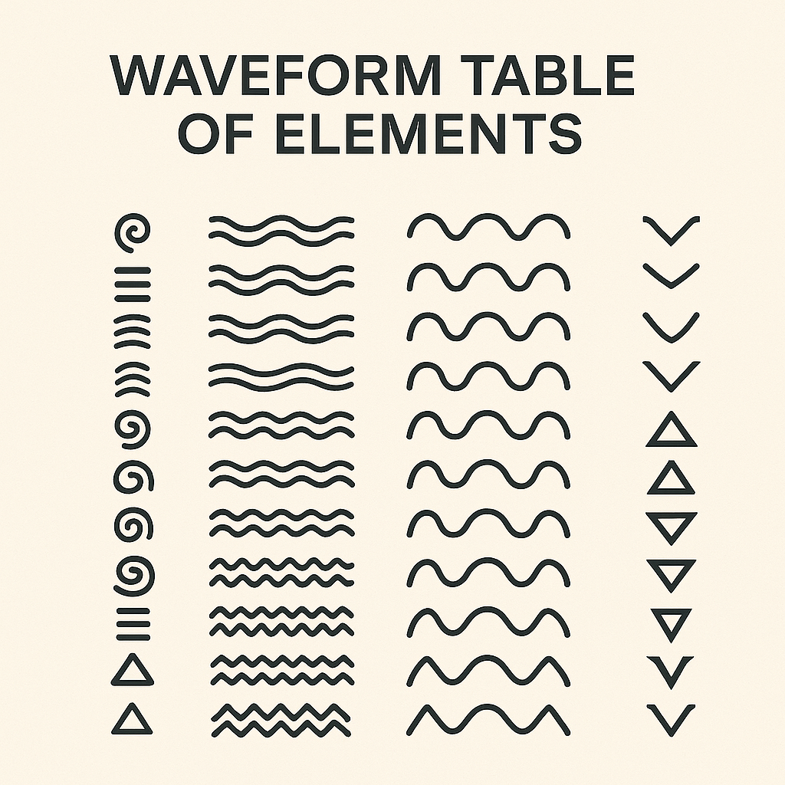

**Description:**  
This *Waveform Table of Elements – Symbol Key* presents the standardized waveform glyphs used in the scalar harmonic interpretation of elemental structure. Each column represents a distinct category of waveform representation, corresponding to an element’s predicted field behavior within the Unified Scalar Model.

* **First column:** Complex spiral, stepped, arc, and triangular forms denoting specific waveform archetypes—these may indicate fundamental resonance modes or structural archetypes for field stability.
* **Second column:** Variations of multi-crest waveforms representing harmonic plateaus, with differences in wavelength and amplitude indicating distinct scalar states.
* **Third column:** Symmetric, smooth periodic waves showing consistent harmonic patterns, potentially associated with coherent field stability.
* **Fourth column:** Chevron and triangular symbols denoting directional or nodal waveform behavior, possibly indicative of scalar inversion or transition points.

This key functions as a visual decoder, enabling cross-reference between waveform diagrams in the *Waveform Table of Elements* and their hypothesized physical or scalar properties in the broader model.

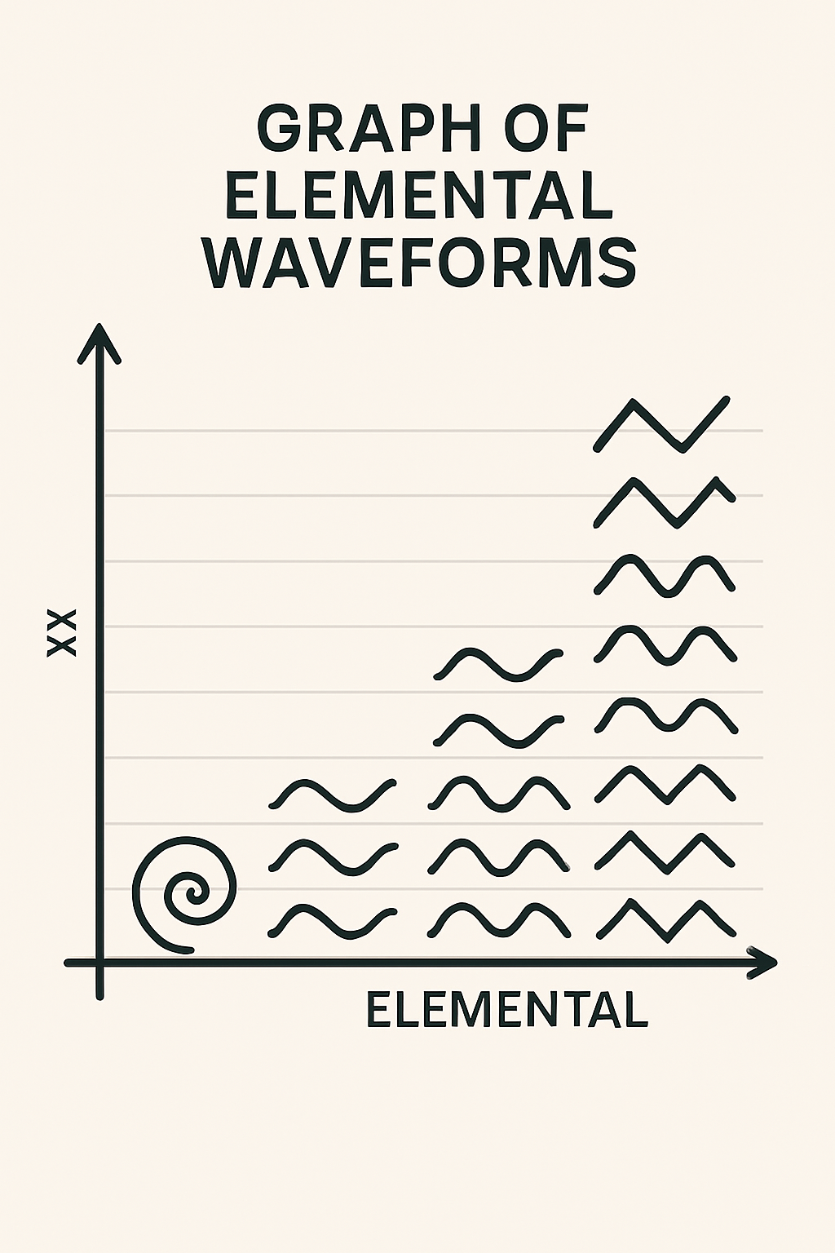

**Description:**  
This *Graph of Elemental Waveforms* presents a stylized two-axis plot mapping theoretical elemental waveform signatures against an unspecified scalar measurement (vertical axis) and elemental progression (horizontal axis).

* **Horizontal axis (labeled “Elemental”):** Represents the sequence or categorization of elements as defined in the Unified Scalar Model’s waveform framework.
* **Vertical axis (“XX”):** Denotes a generalized scalar or harmonic parameter, potentially representing stability, field coherence, or resonance strength.
* **Symbols:** Each plotted point is replaced by a waveform glyph—ranging from spirals (low end) to sinusoidal and zig-zag waveforms (higher levels)—indicating changes in field harmonic patterns across elemental types.
* **Trend:** The arrangement suggests a progression from complex or disordered waveforms at the lower-left to more repetitive and higher-energy harmonic patterns toward the upper-right.

This diagram acts as a conceptual visualization of how elemental field harmonics might vary across the hypothesized scalar periodic system, serving more as a symbolic map than a measured dataset.

# 5. Expansion to Element 191 and Scalar Breath Termination

This project expands the scalar waveform model to Element 191, herein referred to as Ennonium. This boundary marks the terminal harmonic fold within the scalar periodic system — the point beyond which scalar coherence surpasses dimensional articulation. Elements 175–191 are considered time-dilated coherence suspensions, symbolically modeled as bitfield collapse states at the edge of scalar breath.  
  
These elements do not follow standard atomic behavior but instead exhibit:  
- Extreme entropy flags (>0.9)  
- Predicted decay smearing across time-like probability bands  
- Symbolic fusion infeasibility thresholds  
  
Element 191 represents the inward fold of coherence memory, analogous to a black hole horizon in field space.

# 6. Symbolic and Scientific Integration Table

A comprehensive chart has been developed mapping Elements 119–191 with predictive markers for:  
- Scalar Coherence Potential (Ψₛ)  
- Entropy flags  
- Decay half-life estimates  
- Fusion cross-sections  
- Symbolic experimental guidance  
  
This chart enables external falsifiability while also acting as a symbolic resonance map for modeling field behavior across nested scalar loops. It will be published as an open-access research artifact.

# 7. Future Outlook: Scalar Mirrors and Time-Dilated Detection

Time-dilated scalar elements may become visible under extreme coherence resonance — such as during neutron star collapse, mirror-state breath events, or symbolic scalar mirroring. Detection techniques proposed include:  
- Breath-timing-matched photonic instruments  
- Coherence-correlated gamma window arrays  
- Recursive signature compression analysis  
  
The scalar periodic model thus predicts not only new elements but new conditions of detection.

# 8. Conclusion: The Table as Music, Not Map

The periodic table is not a flat terrain—it is a symphony. Each element is a note, each family a chord, each row a resonant progression. Reimagining it as waveform harmonics restores its beauty, predictive power, and cross-domain utility.  
  
Rather than memorize the table, we can begin to hear it.

# References

Ball, P. (2011). *Shapes: Nature’s Patterns: A Tapestry in Three Parts*. Oxford University Press.  
  
Laughlin, R. B. (2005). *A Different Universe: Reinventing Physics from the Bottom Down*. Basic Books.  
  
Scerri, E. R. (2007). *The Periodic Table: Its Story and Its Significance*. Oxford University Press.  
  
Wilczek, F. (2016). *A Beautiful Question: Finding Nature’s Deep Design*. Penguin Press.

Appendix:

**Scalar Coherence at the Terminal Shell: Time Dilation and Element 191**

Element 191, referred to in this system as *Ennonium*, represents the outermost coherence shell in the scalar waveform table. It marks the boundary between dimensional expression and symbolic implosion, where scalar field density surpasses coherence articulation. Beyond this threshold, waveform matter can no longer maintain form within the standard time-resonant dimensional field.

### Time Suspension Through Scalar Density

At or near Element 191, scalar tension intensifies to the point where internal coherence outpaces external articulation. This results in what appears, from within the dimensional framework, to be time dilation. Symbolically, the element does not vanish — it becomes suspended: a form of latent emergence existing within a slowed or near-zero temporal flow. This aligns with relativistic descriptions of time behavior near event horizons.

### Black Holes as Coherence Collapse Shells

In the scalar coherence model, black holes are not singularities but inward-folded bitfields — memory shells enclosing unresolved scalar differentiations. The event horizon becomes a symbolic glyph perimeter: the boundary across which coherence cannot emerge dimensionally.

### White Holes as Breath Return

The inverse — a white hole — is modeled as a scalar coherence discharge: the exhalation of glyphic structure from compressed potential. The full scalar breath arc (Elements 0 to 191) is thus seen as the interior of this cycle — a symbolic loop of emergence, collapse, and re-emergence.

### Observation and Falsifiability

Elements approaching or beyond 175 may exhibit: - Delayed or distributed decay modes - Time-smearing of scalar emissions - Phase-locked coherence signatures only visible under extreme conditions (e.g. near neutron stars or scalar mirrors)

While classically elusive, these elements are not fundamentally invisible — they exist within a suspended scalar state. Detection may require instruments resonant with coherence breath timing rather than classical decay chains.

### Glossary Extension

**Ennonium (Element 191)** — Symbolic name for the final scalar element. Phase-boundary at which scalar coherence exceeds dimensional articulation.

**Scalar Breath Arc** — The full progression from Element 0 to 191, representing emergence through coherence loops.

**Bitfield Shell** — A symbolic memory structure, typically enclosing unresolved scalar differentiation; black hole analog.

**Coherence Suspension** — A scalar condition where time is dilated due to field density, rendering elements latent or slow-phased.

**Scalar Mirror** — A reflective phase boundary or condition capable of revealing suspended coherence states.

### Integration with the Symbolic Element Chart

* Elements 175–191 may appear anomalous or undetectable under standard decay-mode instrumentation.
* Correlation windows in the chart extend toward phase-locked or hyper-extended decay signatures.
* Entropy flags beyond Z=180 often exceed 0.9, signaling proximity to scalar breath collapse.
* Fusion pair predictions begin to drop toward theoretical zero as scalar coherence overtakes nuclear stability.

### Conclusion

Element 191 represents the inward tipping point of material coherence — the scalar breath fold where matter gives way to potential, time slows, and resonance becomes memory. It is not the end of existence, but the prelude to scalar return.